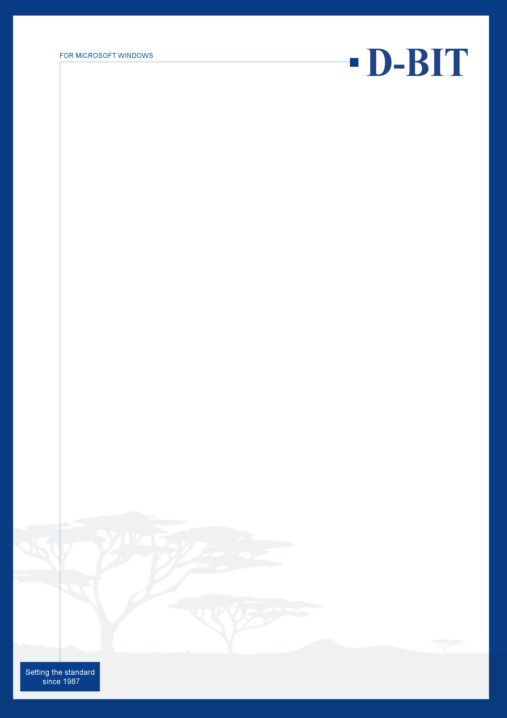

D-BIT Replication
- Even the best hardware in the world can go wrong. If you're doing daily backups then you could loose up to 24 hours worth of data.
- D-BIT Replication is designed to copy (replicate) a database to another location, either within the same or (preferably) another network computer without interrupting users who are working!!
- Replication of data does not replace the requirement for a comprehensive data backup procedure.
- Replication provides a second level of security by making ‘backups’ of your applications databases during the work day.
- When systems fail, conventional backup systems usually mean the loss of the current days transactions Replicating data during the work day minimizes loss of data to the replication interval.
Intelligent backup
  - When an application adds, modifies or deletes records many data tables may be affected concurrently. D-BIT Replication knows the relationship between data tables to ensure that transactional integrity is preserved in the replicate set.
  - Historical data tables are generally larger than Current data tables. D-BIT Replication is optimized to replicate Current data tables independently of historical tables to maximize efficiency.
No interruption:
  - Replicate your data at any time, even during peak use hours, with no interruption of service to the application user.
  - Command line parameters allow D-BIT Replication to be embedded into your choice of scheduler, allowing fully automated operation.
Easy-to-use
  - Automatically detects D-BIT applications and the associated company data files;- without manual updates to file lists.
  - Seamless eMail integration advises administrators if intervention is required.
  - Discrete log of each replication process.
Point-In-Time Recovery
  - Guarantees that you back up a consistent set of data every time.
  - Restoring replicated data (in the event of failure) reinstates the application data to the point-in-time when the last replication succeeded.
  - Schedule the replication of critical applications to match business risk.

